5 Reports generated:

1. Report #1
   1. Description of Query Report (including purpose, benefit, use in business metric, etc): For a given open job requisition, we want to identify if there are any positions that have zero current open applications. If there are no open applications, that means that we should either take a look back at the job requisition posting to review if that needs to be adjusted in some way, or if the open requisition should be re-posted for potential applicants to find. This query returns the number of closed applications, open applications, and total applications grouped by job requisition id. In particular for this query, we only show job requisitions where the number of open applications is 0 and the number of closed applications is not equal to zero.
   2. SQL statement code

create table job_req_applications_support_1 as

(select job_req_id, count(*) as Count_0

from MAZ18012.job_req_applications

where application_status = 0

group by job_req_id

);

create table job_req_applications_support_2 as

(select job_req_id, count(*) as Count_1

from MAZ18012.job_req_applications

where application_status = 1

group by job_req_id

);

select distinct jra.job_req_id, nvl(supp_1.Count_0, 0) as "Closed_Applications", nvl(supp_2.Count_1,0) as "Open_Applications", nvl(supp_1.Count_0,0) + nvl(supp_2.Count_1,0) as "Total Applications"

from MAZ18012.job_req_applications jra left join job_req_applications_support_1 supp_1

on jra.job_req_id = supp_1.job_req_id

left join job_req_applications_support_2 supp_2

on jra.job_req_id = supp_2.job_req_id

where nvl(supp_2.Count_1,0) = 0 and nvl(supp_1.Count_0, 0) <> 0

order by 1 ASC;

* 1. Output screen shot of report:

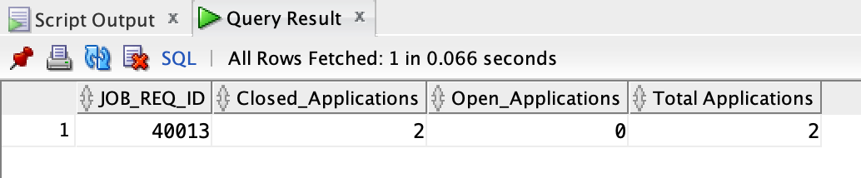

1. Report #2
   1. Description of Query Report (including purpose, benefit, use in business metric, etc): We want to create a list of all candidates who have applied to positions with required skills, grouping the list by the given skill. In doing so we would use this list so that in the case that an applicant is not a fit for the requisition they applied for, other hiring managers can find these candidates who may have the skills required for their positions they are looking to fill. This would allow for retaining good talent and filling the candidates into the best fit positions available. The report generated will show a skill ID, the associated skill name, and all applicant ID’s which have applied to a position which also required this skill. From here the hiring managers and/or human resources representatives can use this list of applicant ID’s to support further engagement with these candidates.
   2. SQL statement code

select rs.skill_id, rs.skill_name, listagg(jra.applicant_id,', ') within group (order by jra.applicant_id) as "Applicants with Skill"

from MAZ18012.job_req_required_skills jrrs left join MAZ18012.required_skills rs

on jrrs.skill_id = rs.skill_id

left join MAZ18012.job_req_applications jra

on jra.job_req_id = jrrs.job_req_id

group by

grouping sets (

(rs.skill_id, rs.skill_name)

)

;

* 1. Output screen shot of report:

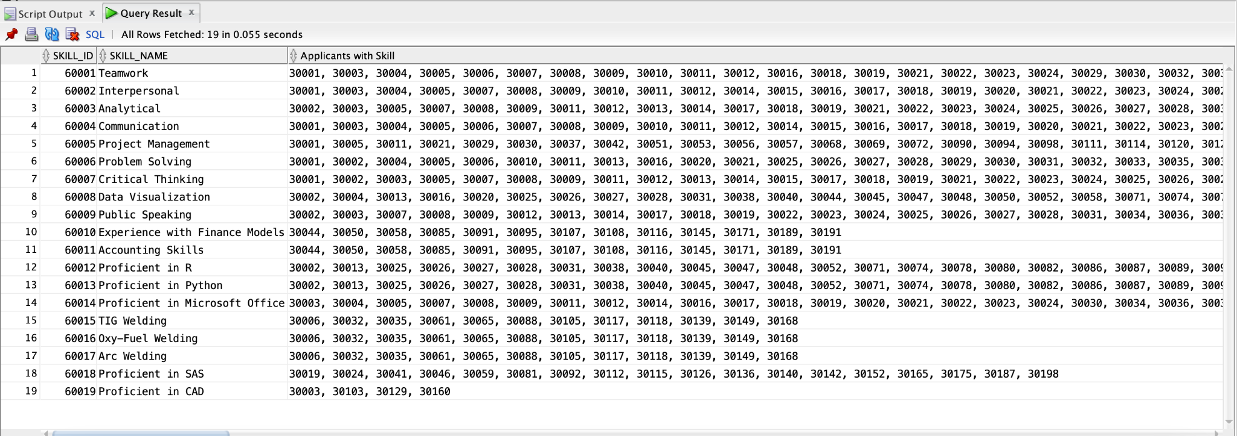

1. Report #3
   1. Description of Query Report (including purpose, benefit, use in business metric, etc): We want to identify open applications in the system that were submitted and which likely have been left open accidentally and were never closed. To do this, we are going to generate a report that will list the following attributes: job requisition number, job application id number, applicant id number, applicant name, the number of days since the application submission, and a confirmation that the application is currently open. This report will be a filtered report which will only show applications older than 90 days and where the candidate never moved past the first application round - again leaving a likely list of applications that were left open which can be officially closed after verification with the hiring manager that this is correct.
   2. SQL statement code

select jra.job_req_id, jra.job_application_id, jra.applicant_id, app.applicant_first_name || ' ' || app.applicant_last_name as "Applicant", round((sysdate - jra.application_date),0) as "Days Since Submission",

(case

when jra.application_status = 1 then 'Open'

else 'Closed' end) as "Application Status"

from maz18012.job_req_applications jra left join maz18012.applicant app

on jra.applicant_id = app.applicant_id

where application_status = 1 and (sysdate - application_date) > 90 and application_round = 1

order by job_req_id ASC

;

* 1. Output screen shot of report:

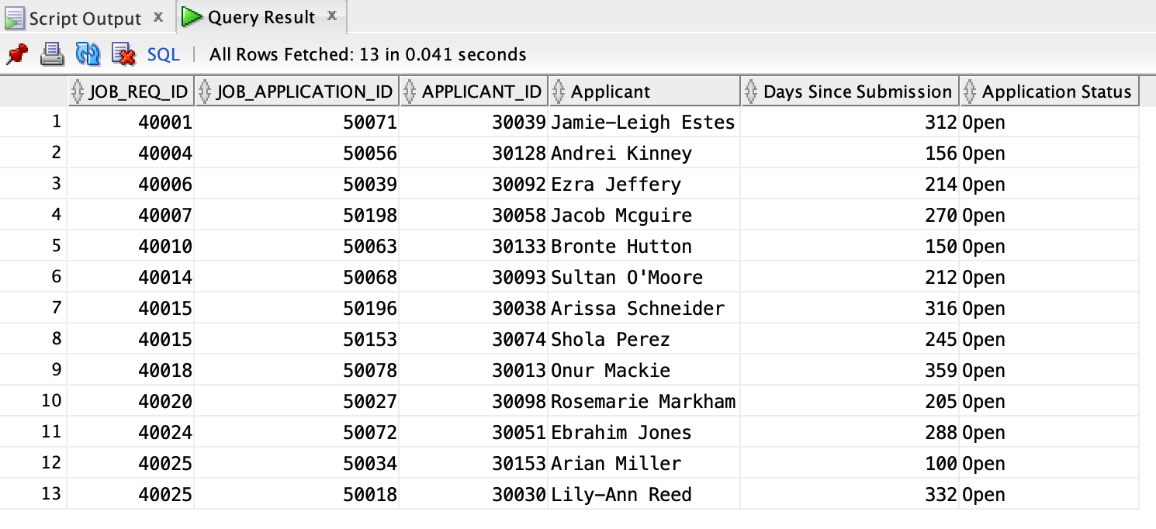

1. Report #4
   1. Description of Query Report (including purpose, benefit, use in business metric, etc) We would be looking to create a list of associate position level jobs and their required skills and department of hire to use at college job fairs for an organized and methodical strategy of identifying, sifting through, and selecting candidates for interviews. To do this, we are going to generate a report with: job req ID, position title name, position level, job location state, job location town, requested experience, skills required, and human resources contact name.
   2. SQL statement code

select jr.job_req_id, jr.position_title_name, jr.position_level, jr.job_location_town, jr.job_location_state, jr.requested_experience, hr.human_resources_first_name || ' ' || hr.human_resources_last_name as "Human Resources Representative", listagg(rs.skill_name,', ') within group (order by rs.skill_name) as "Required Skills"

from MAZ18012.job_req jr left join MAZ18012.human_resources hr

on jr.human_resources_id = hr.human_resources_id

left join MAZ18012.job_req_required_skills jrrs

on jrrs.job_req_id = jr.job_req_id

left join MAZ18012.required_skills rs

on rs.skill_id = jrrs.skill_id

where position_level like '%Associate%'

group by

grouping sets (

(jr.job_req_id, jr.position_title_name, jr.position_level, jr.job_location_town, jr.job_location_state, jr.requested_experience, hr.human_resources_first_name || ' ' || hr.human_resources_last_name)

)

order by jr.job_location_town, jr.job_location_state, jr.position_title_name;

* 1. Output screen shot of report:

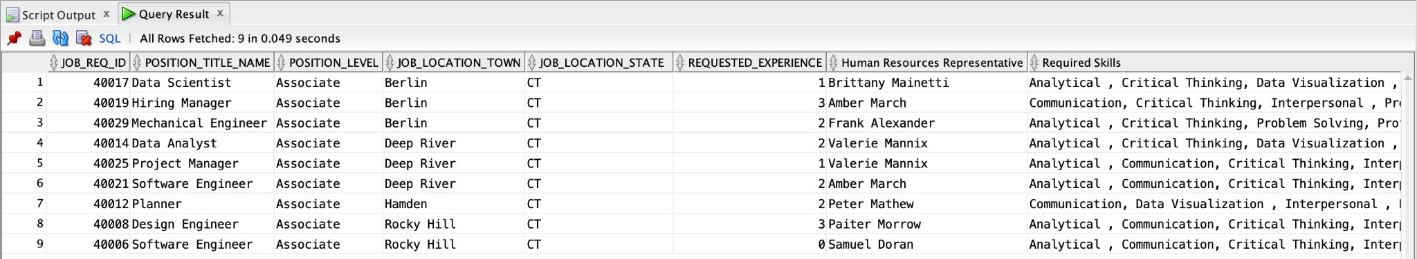

1. Report #5
   1. Description of Query Report (including purpose, benefit, use in business metric, etc) This report would be used to identify and create paths for potential employees who wish to have senior positions in the company but did not quite meet requirements. This would be a leadership identification and mentorship tool for the company to train and/or mentor specific employees to help prepare them for those senior positions in the future. This query would look at who applied to senior level positions but did not receive offers, rank them in their order of application rounds with the higher the application round the higher the possibility of mentorship selection, and then by applicant rank. From there, leaders in the company can further review these applicants and decide who should be receiving specific mentorship. This query filters out any applicants which did not get past the first round using a subquery, which only returns individuals who made it to either round 2 or 3 in the application process, and then additionally only selecting those who are applying for senior positions and have formally had their application closed and have not been hired for the open requisition. The query will return the job application id number, the job requisition number, the position title name, the applicant ID number, the applicant name, the application round, the applicant rank for the position applied for, and a confirmation of the hiring process decision.
   2. SQL statement code

select jra.job_application_id, jra.job_req_id, jr.position_title_name, jr.position_level, jra.applicant_id, app.applicant_first_name || ' ' || app.applicant_last_name as "Applicant Name", jra.application_round, jra.applicant_rank, (case

when jra.application_status = 0 then 'Not initially selected for hire'

else 'Application Open' end) as "Hiring process decision"

FROM maz18012.job_req_applications jra left join maz18012.job_req jr

on jra.job_req_id = jr.job_req_id

left join maz18012.applicant app

on app.applicant_id = jra.applicant_id

where application_round > ANY (

SELECT jra.application_round

FROM maz18012.job_req_applications jra left join maz18012.job_req jr

on jra.job_req_id = jr.job_req_id

WHERE jr.position_level = 'Senior'

)

and jr.position_level = 'Senior'

and jra.application_status = 0

order by jra.application_round DESC, jra.applicant_rank ASC;

* 1. Output screen shot of report:

